YW SUMMER CAMP!

WHAT? Stake YW Summer Camp

WHERE? Bogue Chitto State Park (a few miles north of Folsom, LA—on Northshore)

WHEN? MONDAY June 3 to THURSDAY June 6
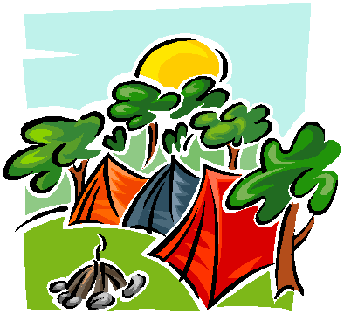

************More details to follow shortly******************

