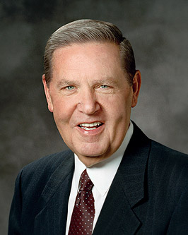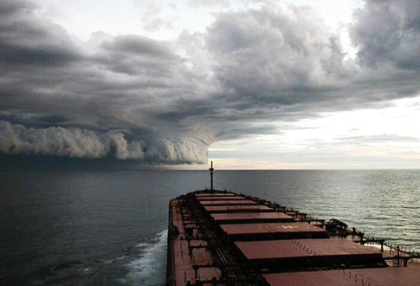

09/03 Kayla Firmin

## YW Leaders

## Events

## Birthdays

Standards Night

On Sunday, September 30th, 2012 at 6pm, the Youth of the New Orleans Stake will renew their energy to “Rise to the Gold Medal Standard”. This will be a Standards Night to remember, of Olympic proportions!

The Theme of this meeting is RISE to the GOLD METAL STANDARD. The 2012 youth theme is Jeremiah 6:16-fishers and hunters. Our objective is to help youth, parents, family members, membersli

Continued on page 2

President Holy Crosby

(480) 294-0358

1st Counselor Tia Castellon

(504) 941-1325

09/30 Youth Standards Night

September 2012

Westbank 1st Branch YW

Hurricane Isaac

Relief Efforts

We are pleased that all of you have made it through another storm with little-to-no damage, although some weren’t as fortunate. Mormon Helping Hands, a priesthood church program providing community service and disaster relief to those in need, has been actively participating in the rebuilding of our community. More than 1,000 members of the Church from Florida, Alabama, Mississippi, and Louisiana have been assisting the victims of Isaac with the cleanup effort. This organization is still in need of volunteers. This would be an excellent service project for our youth, 14 years and older. If you are interested in volunteering or if you know someone in need please contact or Branch President.

Our normal church hours have resumed and we will continue to meet on the 3rd hour and every Tuesday night at 7pm in the Relief Society room for activities.

…And adult leaders to internalize the standards set forth by modern day prophets. The material will come from the Strength of the Youth pamphlet. The Wesbank 1st Branch Youth are responsible for displaying the importance of family and friends.

It has been asked that parents arrive at 5:20pm. This will give our youth the time to prep and rehearse any necessary material. This event will be open to parents, friends, family members, and leaders. Please arrive on time because we cannot guarantee parking or comfortable seating.

_______________________________________

How to Be a Woman of God

Elder Jeffrey R. Holland

*New Era,* August 2012

Elder Jeffrey R. Holland teaches that your Father in Heaven knows what you can become through faith in Him. “I want you to be proud you are a woman. I want you to feel the reality of what that means. You are literally a spirit daughter of heavenly parents with a divine nature and an eternal destiny.”

(Continued)