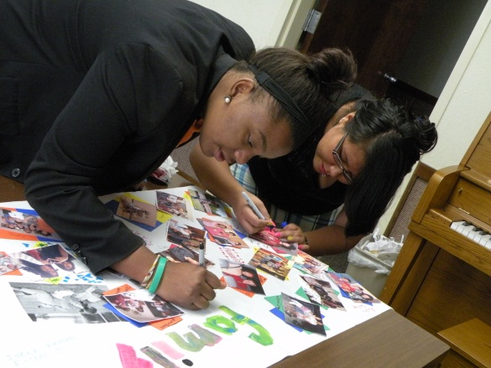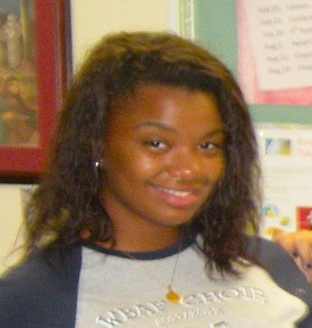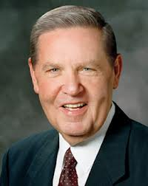

Standards night was a big success! Thanks to all the hard work from our Young Men and Young women. They really Rose to the Gold Medal and put on an excellent show, displaying the importance of family and friends.

A big THANK YOU to all of our parents, for your continuous support. Without your attendance and helping hands, this event would not have been possible.

### Events/Birthdays

10/05 – Tori Moesle

10/26 – Fall Festival

Leaders

President Holly Crosby

(480) 294-0358

1st Counselor Tia Castellon

(504) 941-1325

Westbank 1st Branch YW

OctuBRE 2012

# Standards Night

# YW Recognition

Madelyn was born July 18, 1994, in the Dominican Republic. She is multilingual and the eldest of 6 siblings. Madelyn is a second year Laurel and will be a 2013 John Ehret High School. She enjoys baking and singing. Madelyn hopes to one day serve a mission and attend college.

Madelyn has been an exemplary Young Woman. She has gone above and beyond in meeting the Young women standards. Madelyn displays excellent attendance in Sunday Gospel Instruction, Mutual, and Seminary. She has helped to serve our full-time missionary sisters in teaching the gospel to investigators. Madelyn is always eager to help and fill in were needed.

About Madelyn

###### Madelyn Giron

Your Father in Heaven knows what you can become through faith in Him.

I want you to be proud you are a woman. I want you to feel the reality of what that means. You are literally a spirit daughter of heavenly parents with a divine nature and an eternal destiny. That surpassing truth should be fixed deep in your soul and be fundamental to every decision you make as you grow into mature womanhood.

Your Father in Heaven knows your name and knows your circumstances. He hears your prayers. He knows your hopes and dreams, including your fears and frustrations. And He knows what you can become through faith in Him. Seek to comprehend the significance of these doctrines.

Cherish your esteem place in the sight of God. He needs you. This Church needs you. The world needs you.

If for a time any of you are less visionary than this or seem bent on living beneath your privilege, then we express even greater love for you and plead with you to make your teenage years a triumph, not a tragedy. Fathers and mothers, prophets, and apostles have no motive except to bless your life and to spare you every possible heartache we can spare you.

For you to fully claim Heavenly Father’s blessings and protection, we ask you to stay true to the standards of the gospel of Jesus Christ and not slavishly follow the whims of fads and fashions. Our standards are not socially negotiable.

###### In the recent general conference, prophets of God addressed current issues and stated the official position of the Church on matters of concern. Their teachings provide answers to our questions. I am thankful for President Thomas S. Monson and other latter-day prophets and apostles for they speak the truth.

###### - Mary N. Cook

# Presidency Message

# **How to Be a Young Woman of God**

# Jeffrey R. Holland

# *New Era, August 2012*

## General Conference

General conference was very informative and inspirational. I enjoyed having our Young Women in my home. The spirit was strong and I saw how the message of our prophet and apostles touched the hearts of each Young Woman. Many of the girls are excited about the thought of being able to go on a mission, before the age of 21. As you consider this possibility, please do so with sincere prayer and council from our Branch President.

*“Go . . . and teach all nations, baptizing them in the name of the Father, and of the Son, and of the Holy Ghost”*

-Matthew 28:19

7:00pm – 7:35pm Madelyn Sofia

7:35pm – 8:05pm Mayelin

Melanie

8:05pm – 8:40pm Leilani

Nikia

Jasmine

This year the Young Women will be assisting me in hosting this years annual Fall Festival. They have taken the initiative in passing out flyers and announcing the event, in both Spanish and English speaking Relief Society groups. They have also volunteered to help set up. This means they will need to arrive 30 minutes before everyone else. If anyone should need a ride, please contact any of our Young Women leaders.

As usual we will be hosting the cake walk, it will be held in the Relief Society room, and this is were your help is needed. For those of you that can and are willing to bake, your donations are very much desirable. We are seeking cakes, cupcakes, cookies, and brownies. I know we have asked a lot from you already, but without your charitable contributions this event would not be possible.

If anyone is interested please contact Sister Tia Castellon, (504) 941-1325.

## Cake Walk Schedule

# Fall Festival