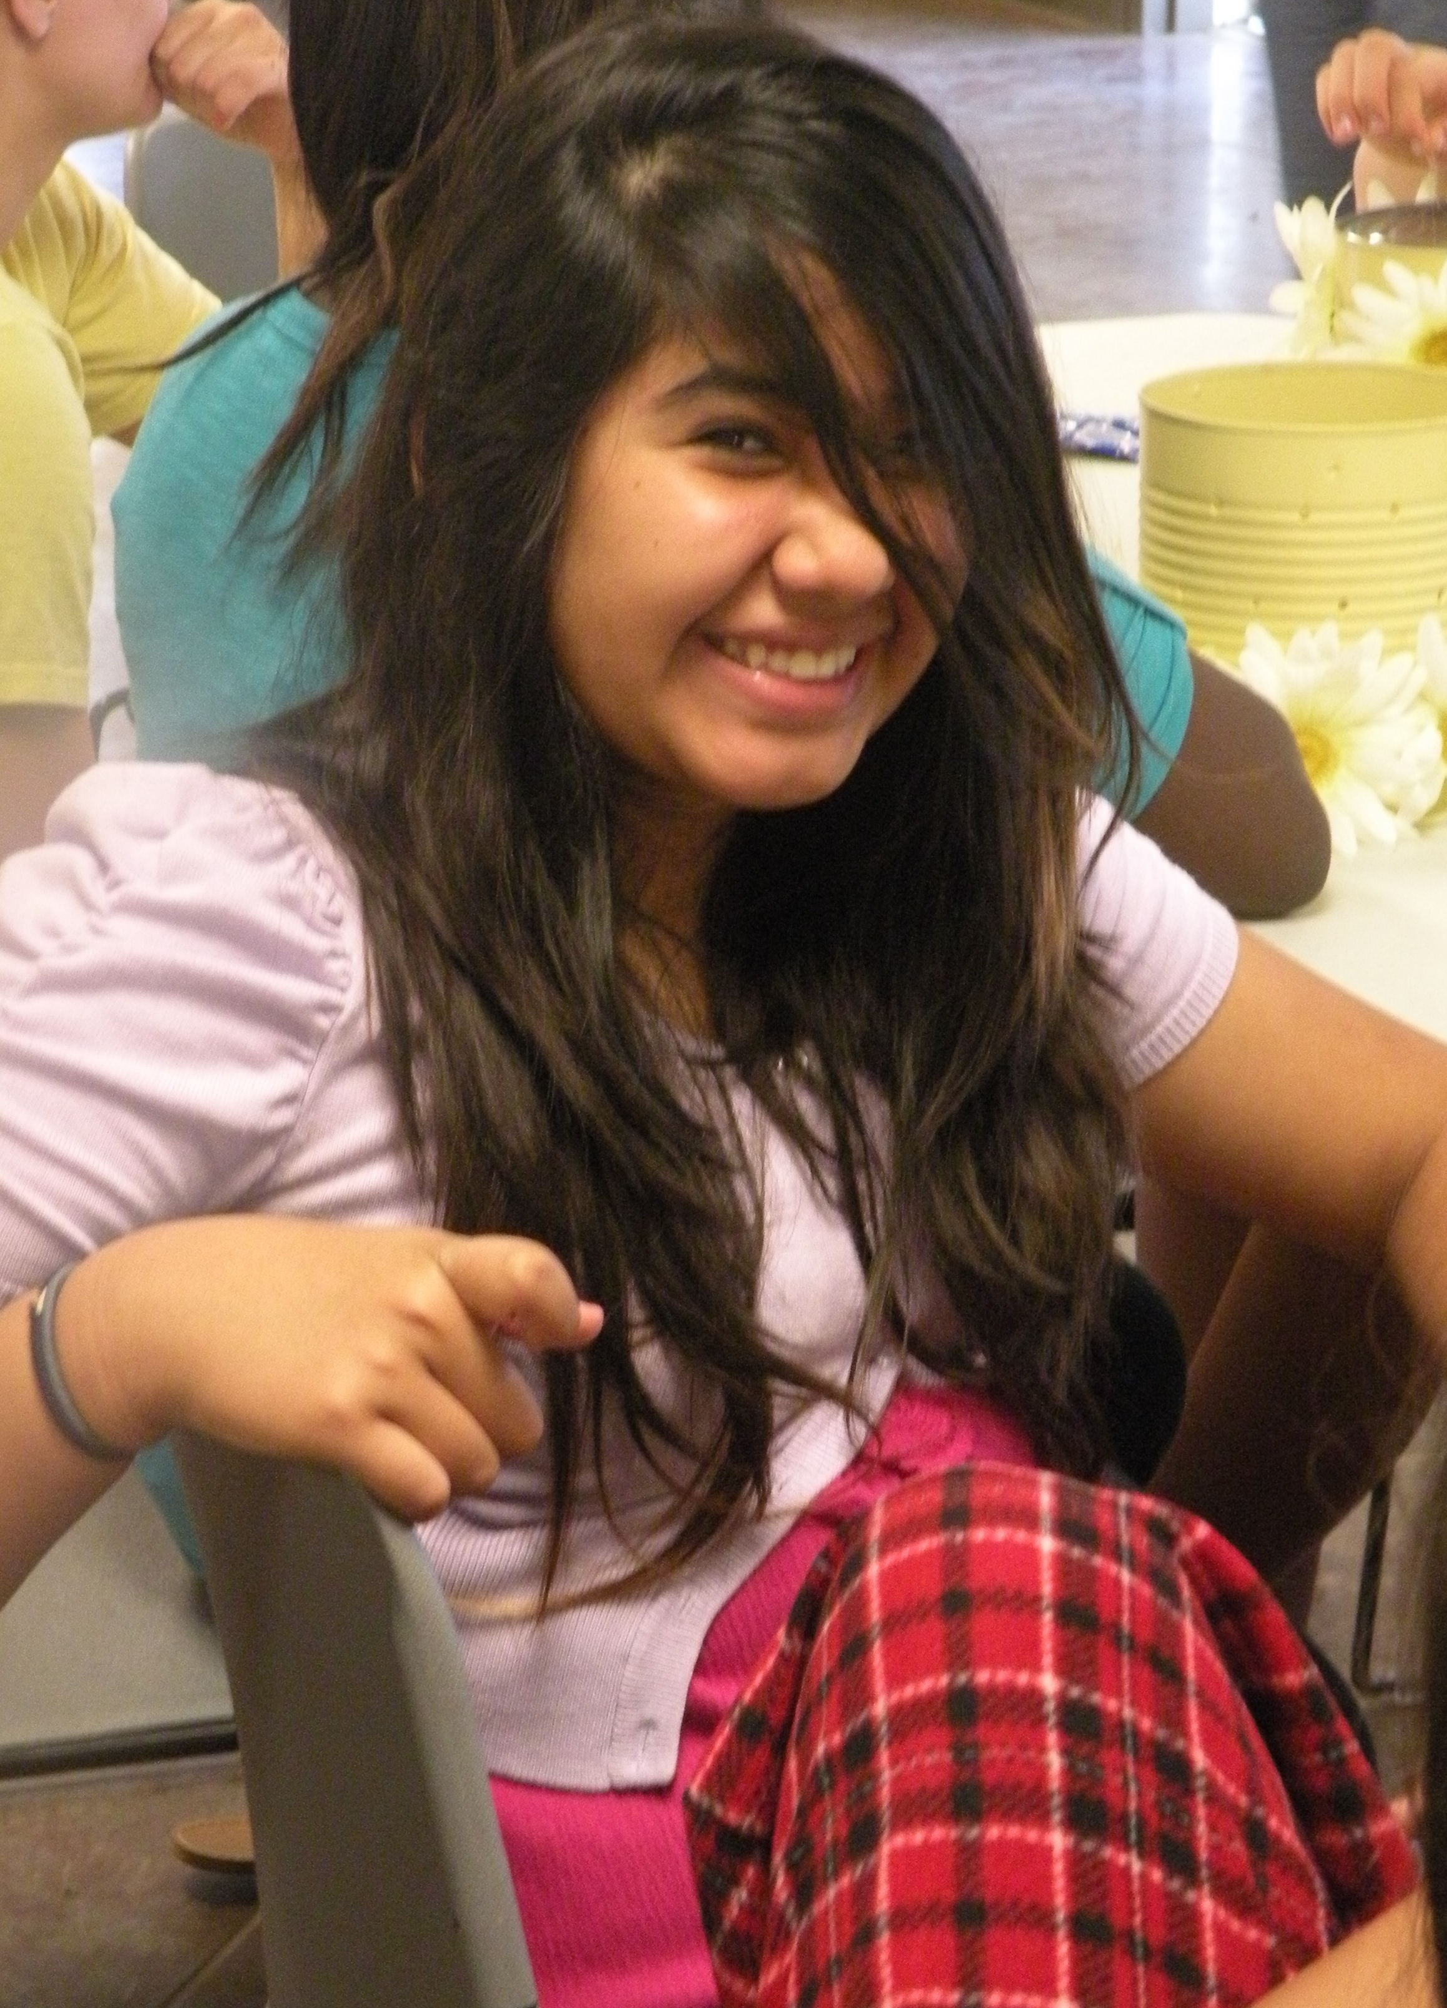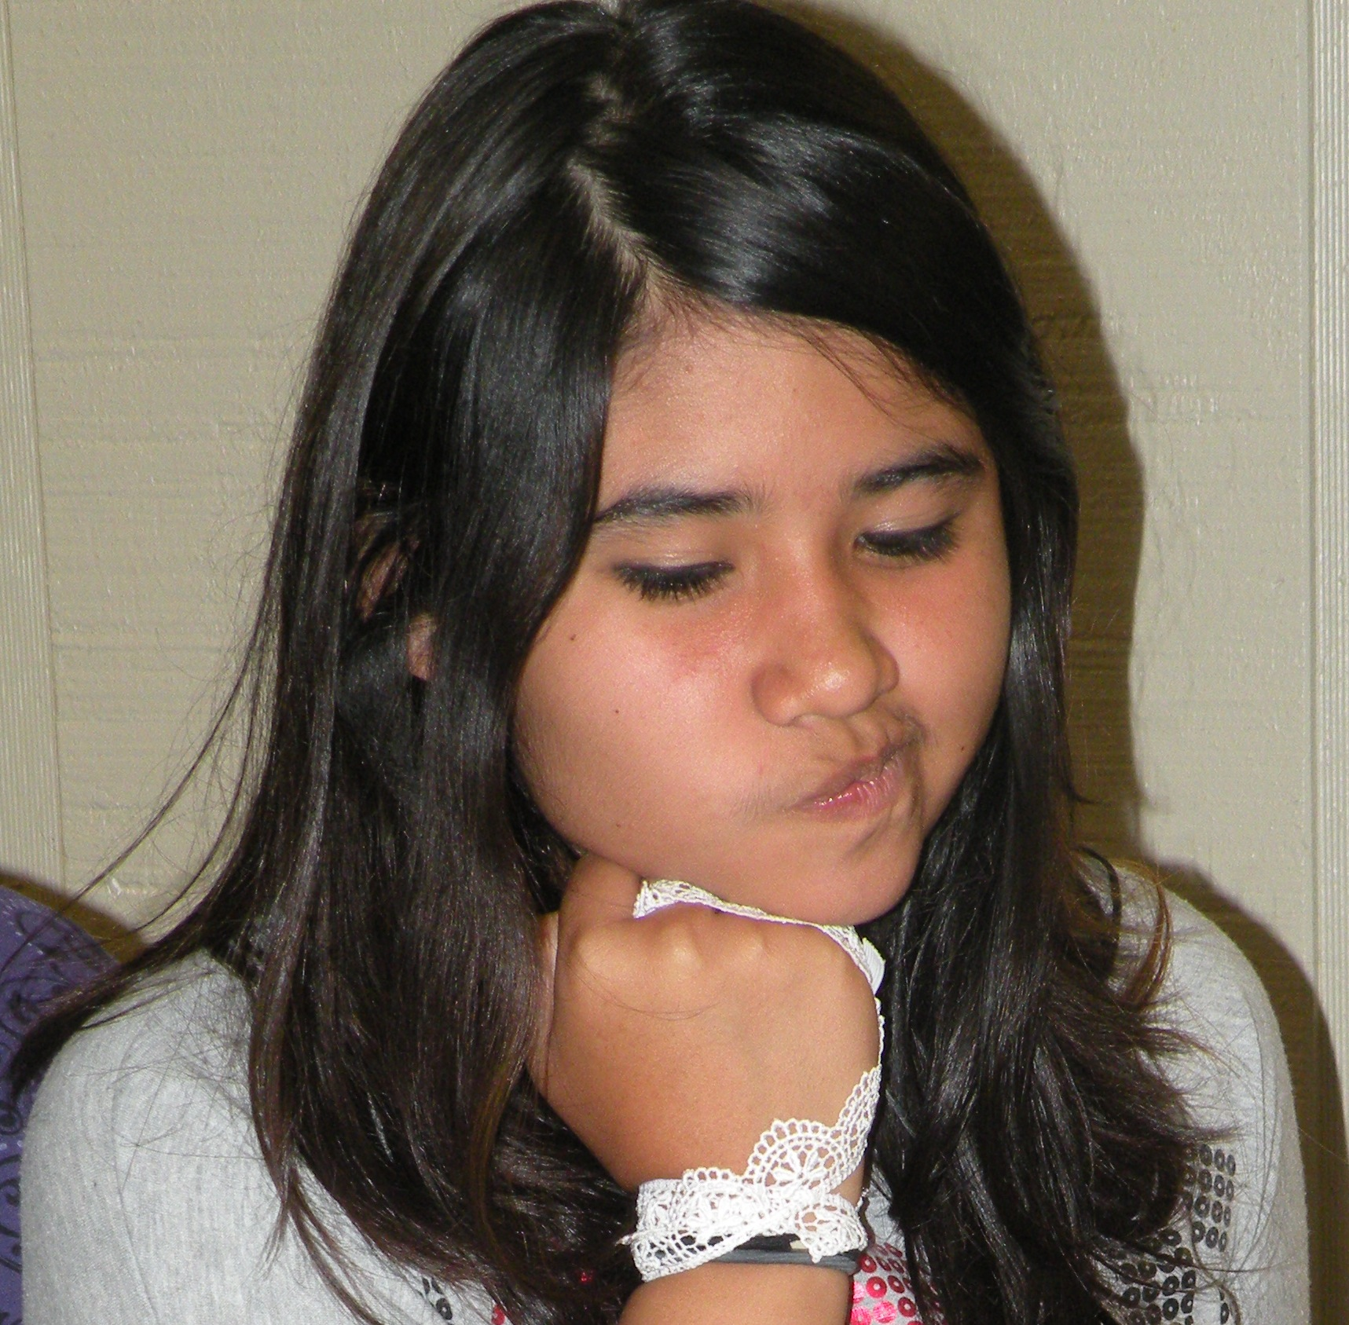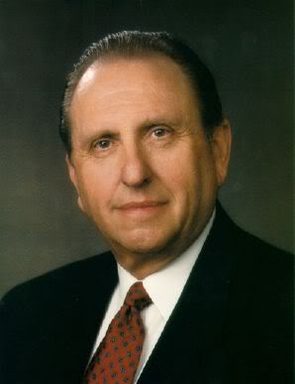

We are sad to regret that Sister Holly Crosby is no longer our YW President. Holly will be greatly missed. We are pleased to announce Tia Castellon as president, Angela Martinez as 1st counselor, Malarie Gossel as 2nd counselor, and Marlie Trujillo as secretary. I hope we will do our best to support these sisters in their callings.

*“Therefore, let every man… labor in his own calling; and let not the head say unto the feet it hath no need of the feet; for without the feet how shall the body be able to stand?’*

(D&C 84: 109)

11/23 – Emily Bish

11/23 – HAPPY THANKSGIVING!

12/07 – Tri-Stake Christmas Dance

Leaders

President Tia Castellon

(504) 941-1325

1st Counselor Angela Martinez

(504) 818-6292

2nd Counselor Malarie Gossel

(504) 316-5788

Secretary Marlie Trujillo

(817) 691-3505

Westbank 1st Branch YW

November 2012

# New Leaders

### Events/Birthdays

Sofia is a second year Beehive. Her talents are texting and playing soccer. She also has her second degree belt in Karate. Sofia’s favorite value is Faith, because she believes in God. Her favorite candy bar is Twix, and she enjoys listening to country, rock, and pop music. Sofia enjoys social studies and science. She hopes to attend Loyola University, and plans on becoming a lawyer. In her spare time she likes hanging out with her friends and reading *My Last Best Friend*. Some of her interests are cooking, gardening, scrapbooking, photography, cleaning, and dancing.

Sofia has demonstrated exceptional leadership skills this past month. She has attended all assigned Sunday Instructional Classes and Mutual Meetings. Sofia was a big help assisting with the Fall Festival. She donated her spare time to help set-up and decorate. She went above and beyond, taking last minute projects home to complete. Sofia is always willing to assist and does her best to come prepared. She demonstrates modesty and an eagerness to achieve. It has been a pleasure getting to know her.

# YW Recognition

All About Sofia

###### Sofia Ortiz

As I contemplated all that you face in the world today, one word comes to my mind. It describes an attribute needed by all of us but one which you----at this time of your life and in this world---will need particularly. That attribute is courage.

Tonight I’d like to talk with you about the courage you will need in three aspects of your life

* First, the courage to refrain from judging others;
* Second, the courage to be chaste and virtuous;
* Third, the courage to stand firm for truth and righteousness.

May I speak first about the courage to refrain from judging others. Oh, you may ask, “Does this really take courage?” And I would reply that I believe there are many times when refraining from judgment---or gossip or criticism, which are certainly akin to judgment---takes an act of courage.

Unfortunately, there are those who feel it necessary to criticize and to belittle others. You have, no doubt, been with such people, as you will be in the future. My dear young friends, we are not left to wonder what our behavior should be in such situations. In the Sermon on the Mount, the Savior declared, “Judge not.” At a later time He admonished, “Cease to find fault one with another.” It will take courage when you are surrounded by your peers and feeling the pressure to participate in such criticisms and judgments to refrain from joining in.

I would venture to say that there are young women around you who, because of your unkind comments and criticism, are left out. It seems to be the pattern, particularly at this time in your lives, to avoid or to be unkind to those who might be judged different, those who don’t fit the mold of what we or others think they should be.

The Savior said:

“A new commandment I give unto you, That ye love one another…

“By this shall all men know that ye are my disciples, if ye have love one to another.”

I turn next to the courage you will need to be chaste and virtuous. You live in a world where moral values have, in great measure, been tossed aside, where sin is flagrantly on display, and where temptations to stray from the strait and narrow path surround you. Many are the voices telling you that you are far too provincial or that there is something wrong with you if you still believe there is such a thing as immoral behavior.

Isaiah declared, ”Woe unto them that call evil good; that put darkness for light, and light for darkness.”

My final plea tonight is that you have the courage to stand firm for truth and righteousness. Because the trend in society today is away from the values and principles the Lord has given us, you will almost certainly be called upon to defend that which you believe. Unless the roots of your testimony are firmly planted, it will be difficult for you to withstand the ridicule of those who challenge your faith. When firmly planted, your testimony of the gospel, of the Savior, and of our Heavenly Father will influence all that you do throughout your life. The adversary would like nothing better than for you to allow derisive comments and criticism of the Church to cause you to question and doubt. Your testimony, when constantly nourished, will keep you safe.

# May You Have Courage

# President Thomas S. Monson

# *April 2009, General Conference*

# Tri-Stake Christmas Dance

Westbank 1st Branch will be hosting this years annual Tri-Stake Christmas Dance, with the assistance of New Orleans 1st Ward. This year’s theme will be Santa’s Workshop. The youth will be asked to come dressed in red or white, red/white shirts for the young men and red/white dresses for the young women. Our ladies should remember to be modest and formal.

The dance activities will include: Christmas pictures and caroling. Upon entrance, each youth will receive a red raffle ticket. This ticket will limit them to one picture with Santa. We have chosen two hymns to sing during the mid-point of the dance, hymns 203 and 204. Let’s do our best to make sure our girls are familiar with both songs.

We are collecting nonperishable food items for our service project. All youth are asked to donate one or more shelf-stable items. We will have collection boxes, dressed as Christmas presents, under the tree in the cultural hall. All contributions will later be donated to the Algiers Food Bank, whom is currently low on food supply.

I know everyone’s calendars are full this time of year. But we are requesting all parents to do their best to participate as a chaperone and carpool. Once again parents we thank you for your support and helping hands.

Incentive Jar

The girls are being rewarded for their participation in their Young Women program. The incentive jar has been an encouragement for them to come to class and come prepared. For their attendance and every piece of scripture they bring, they are able to place one marble in the jar. For every personal progress project they complete, they are able to place five marbles in the jar. Once the jar is half full they are rewarded with a pizza party. When the jar is completed filled they will get an ice cream party.

Well… They did it! The jar is half full, and we will be celebrating Tuesday, November 13th, after our mutual meeting. We are going to have a pizza party in the Relief Society room, and we are inviting all parents to attend. Parents, thank you for being encouraging and persistent!