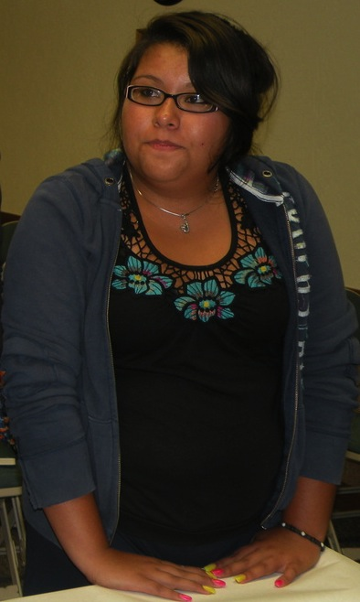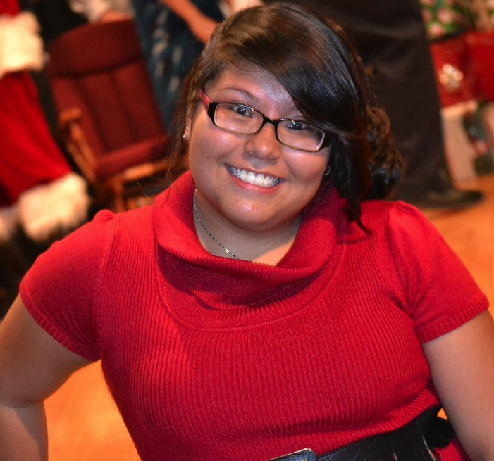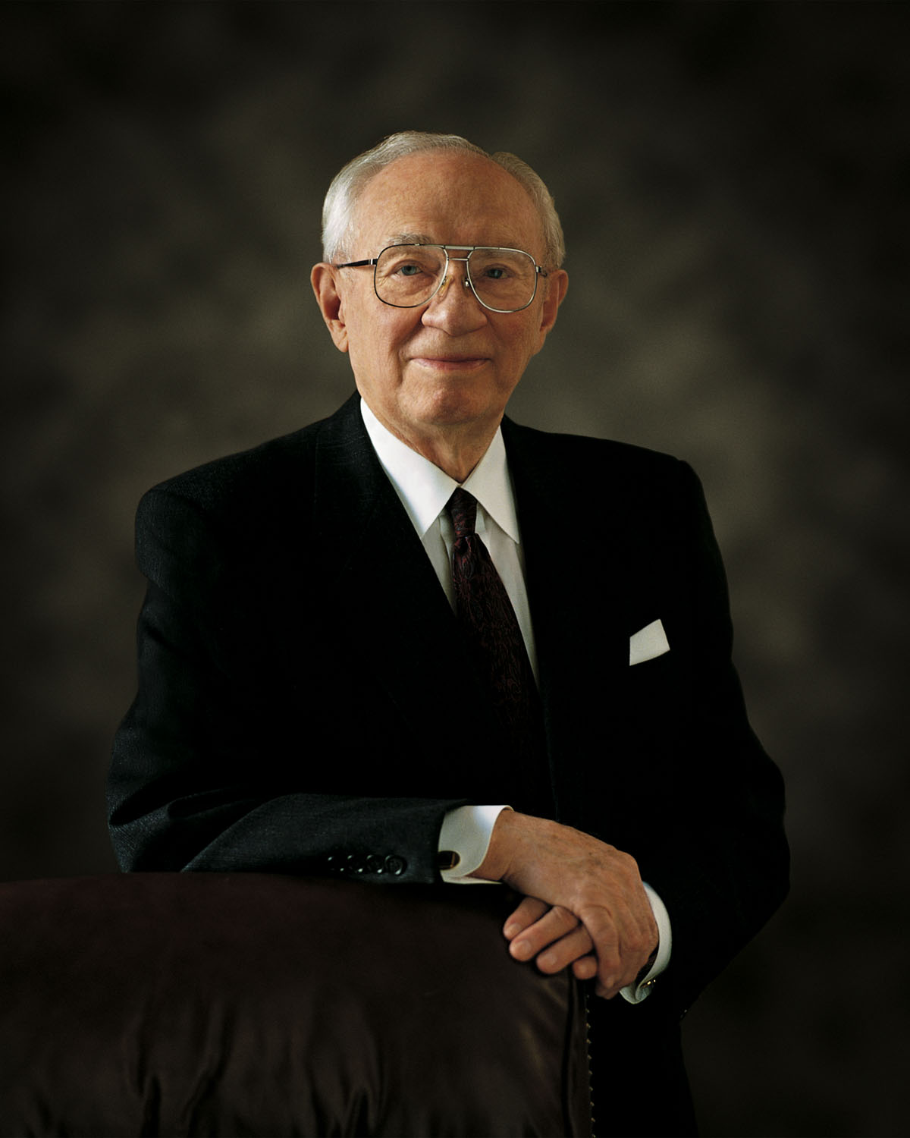

01/09 Mayelin Giron

01/25 Starts Mardi Gras Parking

02/16 Multi-Stake Youth Fireside and Dance

06/3-6 Summer Camp

Leaders

President Tia Castellon

(504) 941-1325

1st Counselor Angela Martinez

(504) 818-6292

2nd Counselor Malarie Gossel

(504) 316-5788

Secretary Marlie Trujio

(817) 691-3505

This year Mardi Gras will start a week earlier, January 25th. There will be no Westbank parades! All parades and parking will be held Uptown at our St. Charles location, 3613 St. Charles. All girls are encouraged to attend. Any funds that are made will go towards summer camp fees. In order for the girls to earn the total amount, they must attend at least 2 parades. All parents are encouraged and invited to attend as well, anyone interested please see our YW President.

Any girls wiling to participate in our Monday parades MUST be accompanied by parents, this will count as a family home evening activity. If there is any girl that is uncomfortable doing this and would like to earn their camp fees another way, please see our YW President for alternative fund raising options.

We are going to have a great time! I look forward to seeing all of you there!

Westbank 1st Branch YW

### Events/Birthdays

# Mardi Gras Parking

January 2013

## Leilani Chavez

Leilani is a very intelligent and has a tender heart. Although Leilani is soft spoken, she is always eager to help and has compassion for her peers. Leilani is an excellent leader and well versed in the gospel and her studies.

Leilani has been an excellent example of being temple worthy. We are all very proud of her and her accomplishments.

Leilani is from Mexico and a first year Mia Maid. She has one sibling and a dog named Beignet. She enjoys photography, sports, babysitting, dance, and crafts. Her hobbies are listening to One Direction and hanging out with her friends. Because of her love of music, Leilani wants to learn how to play the piano and guitar. Her favorite color is purple, and her favorite food is enchiladas.

When Leilani graduates from high school, she plans on attending Harvard and becoming a lawyer. Leilani hopes to one day marry in Paris and be a mother.

All About Leilani

# YW Recognition

Three Distinct Beings

And so I believe in God the Eternal Father, and in His Son, Jesus Christ, and in the Holy Ghost.

I was baptized in the name of these three. I was married in the name of these three. I have no question concerning Their reality and Their individuality. That individuality was made apparent when Jesus was baptized by John in Jordan. There in the water stood the Son of God. His Father’s voice was heard declaring His divine sonship, and the Holy Ghost was manifest in the form of a dove (see [Matt. 3:16–17](https://www.lds.org/scriptures/nt/matt/3.16-17?lang=eng#15)).

I am aware that Jesus said they who had seen Him had seen the Father. Could not the same be said by many a son who resembles his parent?

When Jesus prayed to the Father, certainly He was not praying to Himself!

They are distinct beings, but They are one in purpose and effort. They are united as one in bringing to pass the grand, divine plan for the salvation and exaltation of the children of God.

In His great, moving prayer in the garden before His betrayal, Christ pleaded with His Father concerning the Apostles, whom He loved, saying:

“Neither pray I for these alone, but for them also which shall believe on me through their word;

“That they all may be one; as thou, Father, art in me, and I in thee, that they also may be one in us” ([John 17:20–21](https://www.lds.org/scriptures/nt/john/17.20-21?lang=eng#19)).

It is that perfect unity between the Father, the Son, and the Holy Ghost that binds these three into the oneness of the divine Godhead.

Miracle of miracles and wonder of wonders, They are interested in us, and we are the substance of Their great concern. They are available to each of us. We approach the Father through the Son. He is our intercessor at the throne of God. How marvelous it is that we may so speak to the Father in the name of the Son.

I bear witness of these great, transcendent truths. I do so by the gift and power of the Holy Ghost, in the sacred name of Jesus Christ.

# **Gordon B. Hinckley**

# In These Three I Believe

# *Ensign, July 2006*