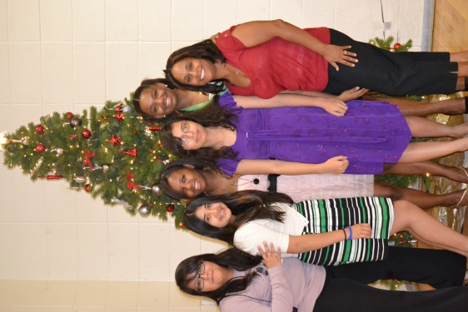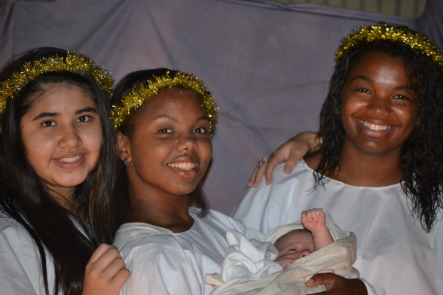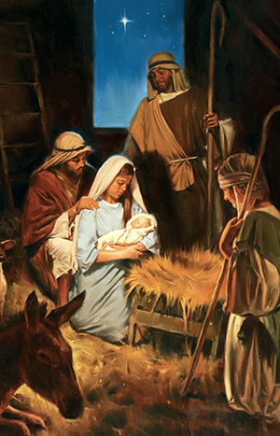

The dance was a big success, our girls did a wonderful job coordinating and decorating. A special thank you to: Madelyn, for volunteering as the evenings photographer, Mayelin, for conducting and leading our Christmas hymns, Sophia, for all her hard work, even though she was unable to attend, and Sister Stancliffe, for always going above and beyond. I would also like to thank our chaperones: Mark Crosby, Holly Crosby, and Raylee Stevens.

The Stake Presidency has acknowledged how dedicating and hard working our Branch has been, and they thank everyone who participated in making this event possible.

12/06- Aubrey Daboval

12/08- Jasmine Green

12/11- Caroling

12/15- Branch Christmas Party

12/18- YW in Excellence

12/25- Merry Christmas

01/01- Happy New Year

Leaders

President Tia Castellon

(504) 941-1325

1st Counselor Angela Martinez

(504) 818-6292

2nd Counselor Malarie Gossel

(504) 316-5788

Secretary Marlie Trujillo

(817) 691-3505

Westbank 1st Branch YW

### Events/Birthdays

# Tri-Stake Christmas Dance

December 2012

Mayelin is a first year Laurel and the second eldest of 4 siblings. She was born in Puerto Rico and is bi-lingual. Mayelin can play the piano, lead music, and enjoys working on her Personal Progress. Her favorite YW value is Individual Worth, because it has taught her a lot. Mayelin is interested in Family History, first aid, photography, cooking, babysitting, sports, and gardening. She enjoys roller blading, bike riding, and writing poetry. Her favorite subject in school is French and she likes to learn about history.

Mayelin has definitely earned this month’s YW Recognition. She has gone above and beyond to help plan and prepare for our annual Tri-Stake Christmas Dance. She has donated her spare time to shop for supplies and create decorations. She is always eager and willing to help and participate whenever she is needed.

Meylin brings a positive energy to our group. She is very easy to get a long with and speaks her mind. Mayelin is well versed in her scriptures and an excellent leader.

###### Mayelin Giron

# YW Recognition

All About Mayelin

“When we keep the spirit of Christmas, we keep the Spirit of Christ, for the Christmas spirit is the Christ Spirit. It will block out all the distractions around us which can diminish Christmas and swallow up its true meaning.

“There is no better time than now, this very Christmas season, for all of us to rededicate ourselves to the principles taught by Jesus Christ.

“Because He came to earth, we have a perfect example to follow. As we strive to become more like Him, we will have joy and happiness in our lives and peace each day of the year. It is His example which, if followed, stirs within us more kindness and love, more respect and concern for others.

“Because He came, there is meaning to our mortal existence.

“Because He came, we know how to reach out to those in trouble or distress, wherever they may be.

“Because He came, death has lost its sting, the grave its victory. We will live again because He came.

“Because He came and paid for our sins, we have the opportunity to gain eternal life.” (President Thomas S. Monson, 2011 First Presidency Christmas Devotional)

The Christmas season is a time to reflect and act upon the blessings and opportunities we have because of the birth, life, Atonement, and Resurrection of our Savior, Jesus Christ. As our Heavenly Father “so loved the world, that he gave his only begotten Son” [(John 3:16),](http://www.lds.org/scriptures/nt/john/3.16?lang=eng#15) we express our love toward one another and toward God and his precious Son by giving of ourselves.

*Mix hugs, kisses, smiles, and love until consistent. Blend in holiday cheer, peace on earth, Christmas spirits, and goodwill toward men. Use the mixture to fill a large warm heart. Serve as desired under mistletoe, sprinkle liberally with Christmas Snowflakes. It is especially good when accompanied by Christmas carols and Family get-togethers. Serve to one-and-all, and have a very Merry Christmas!*

½ cup Hugs

4 tsp. Kisses

4 cups Love

1 cup Special Holiday Cheer

3 tsp. Christmas Spirits

3 cups Goodwill Toward Man

1 spring of Mistletoe

1 medium-sized bag of Christmas Snowflakes

# Christmas Joy

# A Small, Snow-Covered Tree

# By Darrell Smart

# *Ensign, Dec.2008*

One day, shortly before Christmas, our third child and first son, Bay, was born. As I said good-bye that evening to my exhausted but joyful wife and left the hospital, the warmth and joy that accompanied the birth of my son overwhelmed the cold chill of that clear December night.

The following December we celebrated the first birthday of our dark-eyed, dark-haired son. The day after Christmas, during an evening of games at the home of my in-laws, our revelry was interrupted by an awful shriek from my mother-in-law: “He’s not breathing!” She had gone to check on Bay, who had been sleeping on her bed, and discovered his cold, lifeless body. We immediately rushed our son to the hospital, attempting CPR on the way. We were grief-stricken to learn that nothing could be done to save his life. He had died from sudden infant death syndrome.

Since then, Christmas has been filled with a much deeper meaning for our family. Each year on Christmas Eve when we take down our other children’s stockings to fill them, one solitary stocking is left on the fireplace mantle. Throughout the remainder of the holiday the stocking serves as a reminder of Bay.

Each year, around the time of Bay’s birthday, my wife and I drive to the cemetery where he is buried. At each visit we find that someone else has arrived before us and placed something on our son’s grave: one year it was delicate, small flowers; the next year, a stuffed bear; the next, a little Christmas tree decorated with miniature ornaments. We have no idea who is responsible; the gifts, which touch us deeply, are never accompanied by a note or card.

When I hinted to my mother-in-law that I knew her secret, she denied responsibility. The following year while she and my father-in-law were serving a Church mission abroad, we again found that someone had placed a gift on our son’s grave. Even after inquiring with other family members and friends, we were unable to solve the mystery.

Ten years after our son’s death, a series of snowstorms prevented us from traveling short distances. As a result, our annual visit to our son’s grave site was delayed until several days after Christmas. When we finally made it, we saw a small, decorated Christmas tree, mostly buried in the snow, standing bravely at the head of Bay’s small grave. The effort it must have taken for someone to get to the cemetery through the heavy snowfall overwhelmed us. Tears streamed down our faces as we realized that someone still shared our grief and loss.

After that, we were more resolved than ever to discover the identity of our benefactor and thank him or her for showing us such compassion. But as we reflected more, we realized that whoever was doing these acts of kindness did not want to be identified. We decided to allow our friend to remain anonymous. We replaced our need to thank our friend with a desire to simply live better.

It is now harder for us to speak ill of or criticize any of our friends or family members, because any one of them may be our anonymous friend.

Often while doing service, my wife and I pause to examine our hearts: are we doing good things to be seen by others or for the pure love of Christ and of our fellowmen?

For us, charity—humble and never seeking its own—is symbolized by a beautifully decorated Christmas tree, half-buried in snow, resting in a quiet cemetery.